# STUDENT DECLARATION

### This is to certify that I have completed the Project entitled “Real Estate Online System” under the guidance of Surya Basnet in partial fulfillment of the requirements for the degree of Bachelor of Information Management at Faculty of Management, Tribhuvan University. This is my original work and I have not submitted it earlier elsewhere.

December, 2019

Signature:……………..

Name: Anjan Pudasaini

# CERTIFICATE FROM THE SUPERVISOR

This is to certify that the project entitled “Real Estate Online System” is an academic work done by Anjan Pudasaini submitted in the partial fulfillment of the requirements for the degree of Bachelor of Information Management at Faculty of Management, Tribhuvan University under my guidance and supervision. To the best of my knowledge, the information presented by him in the project report has not been submitted earlier.

Mr. Surya Basnet

Supervisor

Department of Bachelor in Information Management

KIST college of Management

Date: 03/03/2021

# ACKNOWLEDGEMENT

I would like to take this opportunity to express my profound sense of gratitude and respect to all those who helped me throughout the duration of this project. I acknowledge the effort of those who contributed significantly to my project.

I would like to express my grateful thanks to our teacher **Mr. Surya Basnet** and for providing continuous support and constant source of inspiration in successful completion of the Project. I would like to thank Tribhuvan University for providing us chance and allowing me for this study.

Finally I would like to thank all our friends for making the environment favorable for successful completion of the project.

Anjan Pudasaini (7210/16)

KIST College of Management

# EXECUTIVE SUMMARY

### The report here in includes all the activities done during the project on the topic of "Real Estate Online System”. The project is complete as a part of requirement of Bachelor of Information Management course syllabus at Tribhuvan University.

### “Real Estate Online System” is software developed using PHP is developed so that anyone can easily find the perfect house to buy as well as post their house for sale in our website. The person who wants to post house for sale first need to register with the email address. The Email should must be unique. After registration user can easily post their house which is then shown to the home page with proper details.

# TABLE OF CONTENTS

STUDENT DECLARATION i

CERTIFICATE FROM THE SUPERVISOR iii

ACKNOWLEDGEMENT iiii

EXECUTIVE SUMMARY iv

TABLE OF CONTENTS v

TABLE OF CONTENTS vi

LIST OF TABLE ixi

LIST OF FIGURES viii

LIST OF ABBREVIATION ix

CHAPTER 1 1

INTRODUCTION 1

1.1 Background Study 1

1.2 Introduction of The Organization/System 1

1.3 Current Situation of The Organization/System 2

1.4 Issue or problem 2

1.5 Objective of the project 2

1.6 Methodology 3

1.6.1 Data and information 3

1.6.2 Project Framework 3

1.6.3 Data Dictionary 4

1.6.4 Tools Used 6

1.6.5 Techniques of Project report analysis 6

CHAPTER 2 7

TASK AND ACTIVITIES PERFORMED 7

2.1 Analysis of Task 7

2.2 Analysis of Possible Solution 7

2.3 Requirement Analysis 7

2.3.1 Functional Requirement 7

2.3.2 Non-Functional Requirement 8

2.4 Solution Design 9

2.4.1 Use Case Diagram 9

2.4.2 Sequence Diagram 10

2.4.3 State Diagram 10

2.4.4 Class Diagram 11

2.5 Website Development 11

2.5.1 FrontEnd 11

2.5.2 BackEnd 12

2.6 Testing 12

CHAPTER 3 13

DISCUSSIONS AND CONCLUSIONS 13

3.1 Discussions 13

3.2 Conclusions 13

3.2 Further enhancement 14

References

Appendices

# LIST OF TABLE

Fig 1.6.3.1 Admin login table …………..........………..………………………….…….4

Fig 1.6.3.2 Add property table …………..............….........…………....………….…….5

Fig 1.6.3.3 Room image details table ……………...…………….....….……………….5

Fig 1.6.3.4 Seller details table …………………..…………..................……………….5

Table 2.3.1 Functional Requirement …………………..……………………………….8

Table 2.3.2 Non- Functional Requirement………………..………………………………8

Table 2.6: Test case for adding property and system login...............................................12

# LIST OF FIGURES

Figure 1.6.2 Project Framework …….....………………………………..……....……....9

Figure 2.4.1 Use Case Diagram of Real Estate Online System……..........……....……....9

Figure 2.4.2 Sequence-Diagram of Real Estate Online System……………………....…10

Figure 2.4.3 State Diagram for User Verification…………………………………....…….10

Figure 2.4.4 Class Diagram …………………………...…….....……………….....…….11

# 

# LIST OF ABBREVIATION

CSS Cascading Style Sheets

DBMS Database Management System

HTML Hypertext Markup Language

PHP PHP Hypertext Pre-processor

XAMPP Cross-platform, Apache, Maria db, PHP and Perl

# CHAPTER 1

# INTRODUCTION

## 1.1 Background Study

### The world wide web have spread across most of the household, so naturally, Internet has become by far the best platform for real estate marketing today. Even most of the population are using the internet service, most people in Nepal still rely on various agents for selling as well as buying house for them. They are not seem to make proper utilization of online real estate system which makes the direct contact between buyers and sellers saving customers both time and money.

### Today mobile and web based applications have become a part of our day to day life. With the revolution in mobile computing many great features are added to the field and the mobiles are getting smaller, faster and better as the decade passes. Considering this we have developed an efficient and reliable online real estate web application. Real Estate Online Systemsimply list the property that the buyers can buy and seller can provide the necessary details and contacts to buyers.

## 1.2 Introduction of The Organization/System

### Real Estate Online System is a web based application program. It is developed considering the rapid grown in use of internet and electronic gadgets. Here one individual user who wants to buy his/her property can easily contact the actual seller after looking for particular property at particular location without the involvement of any middleman. Also the one who wants to sell their property can easily find the potential buyers from our system.Real Estate Online System is similar to the other existing property selling web based applications but yet quite different. What makes us different is out easy and simple frontend which can be easily understood by large range of users as well as we focused improving on the responsiveness of our website also. On most of other similar web applications the buyers or sellers seem to have problem in understanding about how they can make the right use of those systems. But in our system, we are highly concerned about the simplicity of our user interface. The individual buyers can easily contact with the individual sellers after looking at the whole details about property provided by the seller. Also the buyer can search for property on his/her intended location. But in order to list the property by seller, he/she must be registered in our system.

## 1.3 Current Situation of The Organization/System

### Currently the system “Real Estate Online System” is in developing phase. The system is developed focusing on people who want to sell their property as well as who want to buy the property without the involvement of middleman or agents. Here the seller registers first before posting their property. Then the seller posts their property with all details on our website and the posted property gets successfully enlisted in our website which then can easily be found by particular customer. The system is being developed continuously by checking for errors and adding new features.

## 1.4 Issue or problem

### Although most of the Nepalese population are already familiar with the use of internet and various web applications, we are not being able to use it effectively for certain tasks like property buying and selling instead we rely on various agents. There are still various middleman as a agent in this business who charge high rate of commission for finding properties and most of the people still rely on them for finding the property they need or to sell their property.

## 1.5 Objective of the project

### Real Estate Online Systemis a web application which helps in making a direct contact of property buyers and sellers from the comfort of their home. This website is a online real estate business through which a user can easily post their property as well as find the perfect property for them. The admin user can change the information regarding property selling and cancellation. The system is very useful for individuals for buying and selling purpose of their property as well as it aims to reduce the time and money spent in search of agents and property. Some basic objective of Real Estate Online System are:

1. Make the centralized platform for posting and selling property.
2. Make the easy direct contact between individual buyer and seller.
3. Helps to save individuals time as well as cost spent in search of property.

## 1.6 Methodology

### There are different methodologies that can be used during the data collection process. For the completion of the project I have chosen an organizational field visit as the main source of the data collection, I have applied the techniques of interview method.

## 1.6.1 Data and information

### Many methods are available for data collection, for the completion of this project I have used following methods:

* **Primary Sources**
* Direct observation of websites
* **Secondary Sources**
* Newspaper’s advertisement.
* Social medias advertisements

## 1.6.2 Project Framework

### Project framework is a combination of processes, tasks, and tools used to transition a project from start to finish. This chapter reveals the proposed method of implementing the project. The important on this is systematic planning and implementation in order to complete system on time.

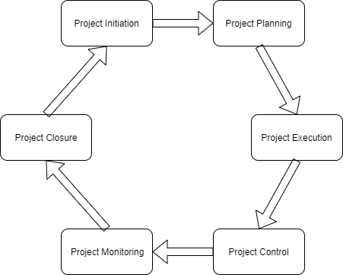

Fig 1.6.2:-Project Framework

* **Project Initiation:** This is the first phase. In this phase first of all the organization was selected, different information about the objective and scope and feasibility of the project was collected. As per the information provided by the concerned person. For further details, the organization was visited. After the approval of the proposal defense, the next phase was started.
* **Project Planning:** In this phase planning was done for who to manage the timeframe within which the project should be finished. Division of the time and work in different modules was done in different categories such as front end ,back end ,data collection, organization visit etc.
* **Project Execution:** In this phase, we prepared questionnaire related with the concerned topic and present them to employees for their response. Beside the questionnaire approach, interview was also taken with the co-owner of the company to know about the working scenario and activities performed by the organization. The details were recorded in the paper The Project Execution Phase is usually the longest phase in the project life cycle and it typically consumes the most energy, time and the most resources.
* **Project Control:** After collecting all information and data about the organization. The adjustment was done to the organization.
* **Project Monitoring**: Project monitoring was done by checking the the project in timely manner.
* **Project Closure:** The Project Closure Phase is the last phase in the project life cycle. In this phase, we prepare reports of overall project and activities. Project Closure involves handing over the deliverables and passing the documentation including all the activities from the scratch level to the completion of the project to the concerned External teachers and presented them visually by using PowerPoint.

## 1.6.3 Data Dictionary

Below shown are the list of data that exists in various tables of the database of the system:

 Fig 1.6.3.1: Admin login table

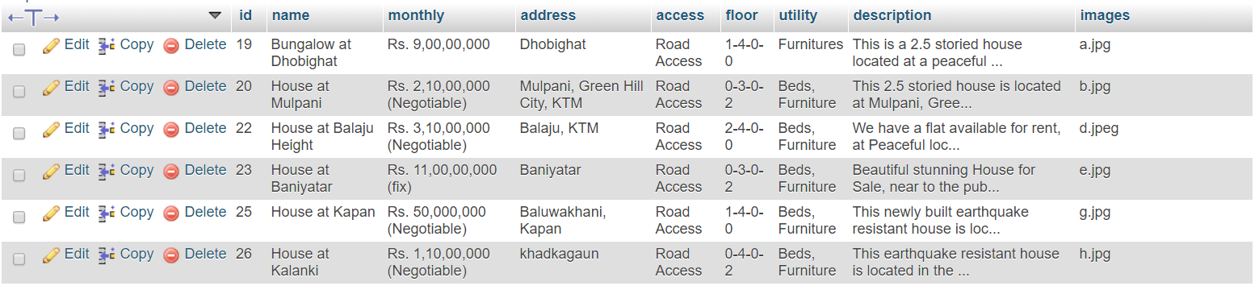 Fig 1.6.3.2: Add Property table

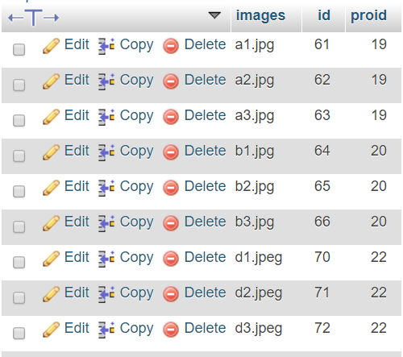

### Fig 1.6.3.3: Room image details table

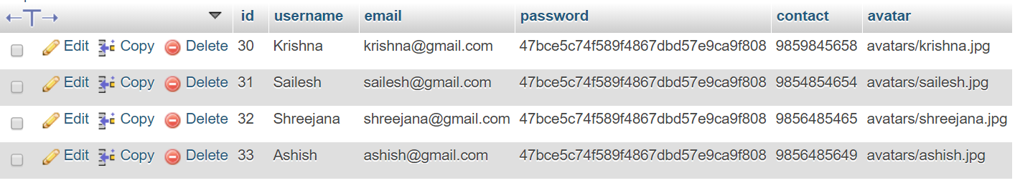 Fig 1.6.3.4: Seller details table

## 1.6.4 Tools Used

## XAMPP Server

### XAMPP is also cross-platform, which means it works equally well on Linux, Mac and Windows. It is used to create a local web server for testing and deployment purposes.. Since most actual web server deployments use the same components as XAMPP, it makes transitioning from a local test server to a live server extremely easy as well.

## Microsoft word for documentation

Adobe The Microsoft word document was used for softcopy documentation of the project. All the Documentation design and numeration are done by using Microsoft word document version 2016.

## Firefox /Google chrome as browser

### Firefox and google chrome was used to run the system. Mainly google chrome is used to run the localhost installed in the computer. As a browser, google chrome is used to run the developed system and collection of information and researches through different websites.

## Brackets text editor

### Brackets text editor was used to write all the codes. Nowadays brackets is widely used by developers who prefer PHP programming language as it provides various extensions and plugins that helps developer to work faster.

## 1.6.5 Techniques of Project report analysis

### Various tools such as UML diagrams are used for the analysis of the software. I have included the full working mechanism of the application and I also have made to use of various diagrams such as sequence diagram, class diagram to represent the working mechanism of the system. I also have described the relationship between various tables in database and how the data gets stored in them and manipulated in database by the use of various database screenshots.

# CHAPTER 2

# TASK AND ACTIVITIES PERFORMED

## 2.1 Analysis of Task

### Many people in our country still rely on various offline middleman for finding and selling their properties. As well as many existing system for performing such tasks are also in limited number. Also they lack a proper features and have messed up user interfaces. There are many issues that the organization is facing in the modern world of technologies. By using this website it might provide support for individual customers.

## 2.2 Analysis of Possible Solution

### The possible solutions that I came up with for the organization are as follows:

* Making the system to enter the check in and check out of the inventories
* Making system that would calculate the available inventories
* Making system that would notify when the reorder is required
* Making system that calculates the inventory related information like EOQ

## 2.3 Requirement Analysis

### Requirement analysis is an important phase of the website development life cycle which provides us all the specification of the website in detail which is very essential to design and build the website. Collecting requirement is a particularly critical stage of the software process as errors at this stage inevitably lead to later problem in the website design and implementation.

## 2.3.1Functional Requirement

### The sellers can register and login into the system by proving necessary details. After successful registration and login, seller can post property, property details and information regarding sale. Some of the functional requirements of the system are listed below:

* Users Login and Registration
* Users Logout
* Admin panel for editing and deleting the property details
* Search Property By Location
* Profile For Registered Sellers

|  |  |  |
| --- | --- | --- |
| **Functional Requirement** | **Importance** | **Description** |
| **Security** | Essential | Use authentication is required |
| **Web Interface** | Essential | Provides interaction between user and database |
| **Database** | Essential | Stores the information |

Table 2.3.1 Functional Requirement

## 2.3.2 Non-Functional Requirement

### Non- functional requirement are the requirements that are not directly concern with specific functions delivered to its users but they are concerned with the emergence website properties such as Reliability, Availability, Safety, etc. Non-functional are as follows**.**

|  |  |  |
| --- | --- | --- |
| **Non-Functional Requirement** | **Importance** | **Description** |
| **Performance** | Essential | Performance of website should be adequate and fast |
| **User-Friendly Environment** | Essential | It should be simple and user friendly |
| **Availability** | Required | website should be available 24 hours |

Table 2.3.2:Non-Functional Requirement

## 2.4 Solution Design

### It is a process of developing abstract of website with each model presenting a different view or perspective of the system. It means representing the website using some kind of graphical notations that is generally based on the notations on the Unified Modeling Language (UML).The design stage takes as its initial input the requirements identified in the approved requirements document. For each requirement, a set of one or more design elements will be produced as a result of interviews, workshops and/or prototype efforts. Different modeling tools and design techniques are used in this like use case diagram, class diagram, sequence diagram etc.

## 2.4.1 Use Case Diagram

### A use case is a description of how a person who actually uses that process or system will accomplish a goal, (Study.com, 2019). The functional requirement of the system can be represented using the use case diagram in following way:

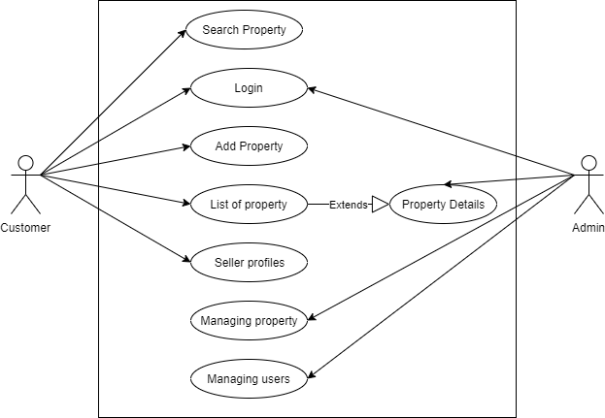

### Fig 2.4.1: Use Case Diagram of Real Estate Online System

The above use case diagram shows If the actor is customer then he/she can login into this system, creates new account, can see the property details. If the user is already an existing user then it can post their properties.

## 2.4.2 Sequence Diagram

### UML Sequence Diagrams are interaction diagrams that detail how operations are carried out. They capture the interaction between objects in the context of a collaboration, (Visual-paradigm.com, 2014).

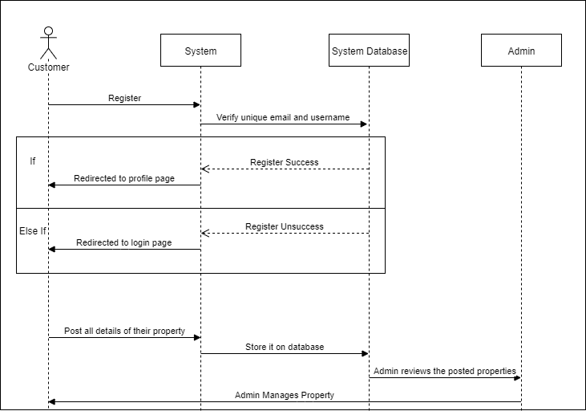

Fig 2.4.2: Sequence-Diagram of Real Estate Online System

## 2.4.3 State Diagram

### State diagram are used to represent the condition of the system or the part of the system at a finite instance of time. It represents the behavior using finite state transitions and is also referred to as state machine and state chart diagram. The diagram below shows the state diagram for user verification:

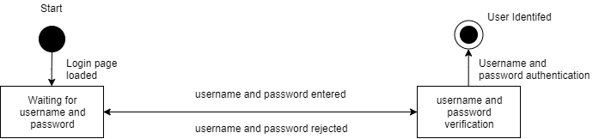 Fig 2.4.3: State Diagram for User Verification

## 2.4.4 Class Diagram

### A class diagram is an illustration of the relationships and source code dependencies among classes in the Unified Modeling Language (UML). In this context, a class defines the methods and variables in an object, which is a specific entity in a program or the unit of code representing that entity. The middle row consists of their attribute whereas the last one is their methods.

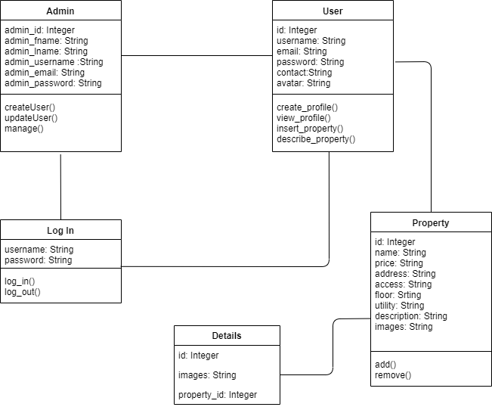 Fig 2.4.4: Class Diagram

## 2.5 Website Development

### Website development is the process of converting a website specification into an executable website. For the development of this website it includes PHP for programming language MySQL for the database for recording the data and many other tools which are given below and classified into FrontEND and BackEnd.

## 2.5.1 FrontEnd

### The front end tools used are:

* **HTML**: Creating buttons, page layout and other forms has been designed in HTML.
* **CSS**: CSS has been used for all the styling part as well as bootstrap to make the website responsive so that it can compatible with all the devices like mobile, laptop , iPad and other devices.
* **Bootstrap**: Bootstrap is nowadays mostly used tool for frontend designs as it already provides ready code and classes for making website more responsive and attractive.
* **JavaScript**: It is used to apply effects, Ajax and much more.

## 2.5.2 BackEnd

### The back end tools used are:

* **PHP**: For my project, I used php for handling the backend data because it gives clarification amongst the Model View and Controller than any other frameworks.
* **MYSQL Database**: MYSQL provides relational database so it has been used as a database for the project so that it will be beneficial to experience the relationship between different entities.

## 2.6 Testing

### Testing is the procedure of the website to trial an input to see whether it produces correct output. It is an empirical investigation conducted to provide customers with the information about the quality of the product or services under test, with respect to the context in which it is intended to operate.

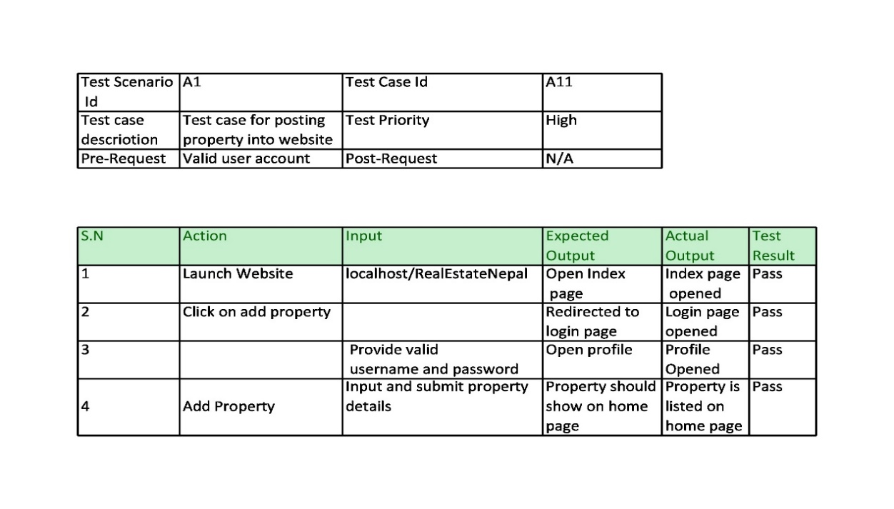

### Table 2.6: Test case for adding property and system login

# CHAPTER 3

# DISCUSSIONS AND CONCLUSIONS

## 3.1 Discussions

### During the project following data and information were discussed. Through the observation and interview many information were collected.

### On that basis this website has been build. The following are the activities that I performed during the development of the system.

* PHP programming was used for the development of the project.
* MySQL Database was used for recording the information that is submitted by the customer or user,

## 3.2 Conclusions

### After completing my project, I have been exposed to a programmer working life. Throughout my project, I could understand more about the definition of programmer and prepare myself to become a responsible and innovative technician and programmer in future. Along my training period, I realize that observation is a main element to find out the root cause of a problem. Not only for my project but daily activities too. During my project, I cooperate with my colleagues and operators to determine the problems. Moreover, the project indirectly helps me to learn independently, discipline myself, be considerate/patient, self-trust, take initiative and the ability to solve problems. Besides, my communication skills is strengthen as well when communicating with others. During my developing period, I have received criticism that it is difficult to build a website. However, those advices are useful guidance for me to change myself and avoid myself making the same mistakes again. Apart from that, I had also developed my programming skills through various programs that I had done. This also helps sharpen my skills in MySQL & PHP. In sum, the activities that I had learned during project really are useful for me in future to face challenges in a working environment. Throughout the project, I found that several things are important:

* Critical and Analytical Thinking
* Time Management
* Colleague Interactions

## 3.3 Further enhancement

Although the project has been completed and able to overcome the problem of the study, there are still many tasks in the system to be enhanced in the future for better performance such as below:

* More Secure login system system
* Online payment gateway will be installed in future.

# References

*1Ropani*. (2009). Retrieved from Real Estate Website of Nepal: http://www.1ropani.com/

*The Realtors*. (2011). Retrieved from The Realtors: https://therealtors.com.np/signup

*W3school*. (1998). Retrieved from A w3school Web Site: https://www.w3schools.com/

# Appendices

**Snapshot of Seller Login and registration**

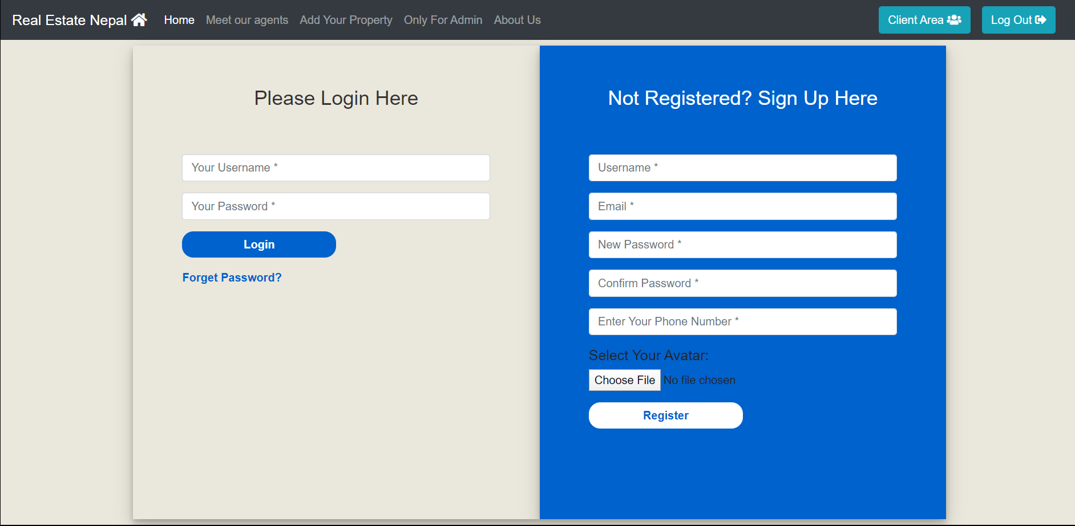

**Snapshot of Admin Login**

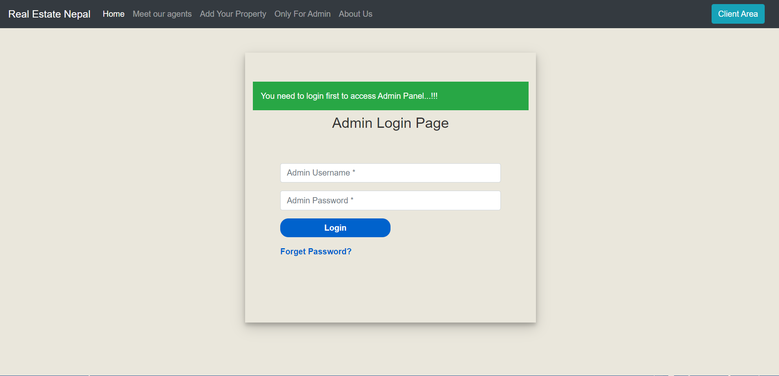

**Snapshot of Property Registration**

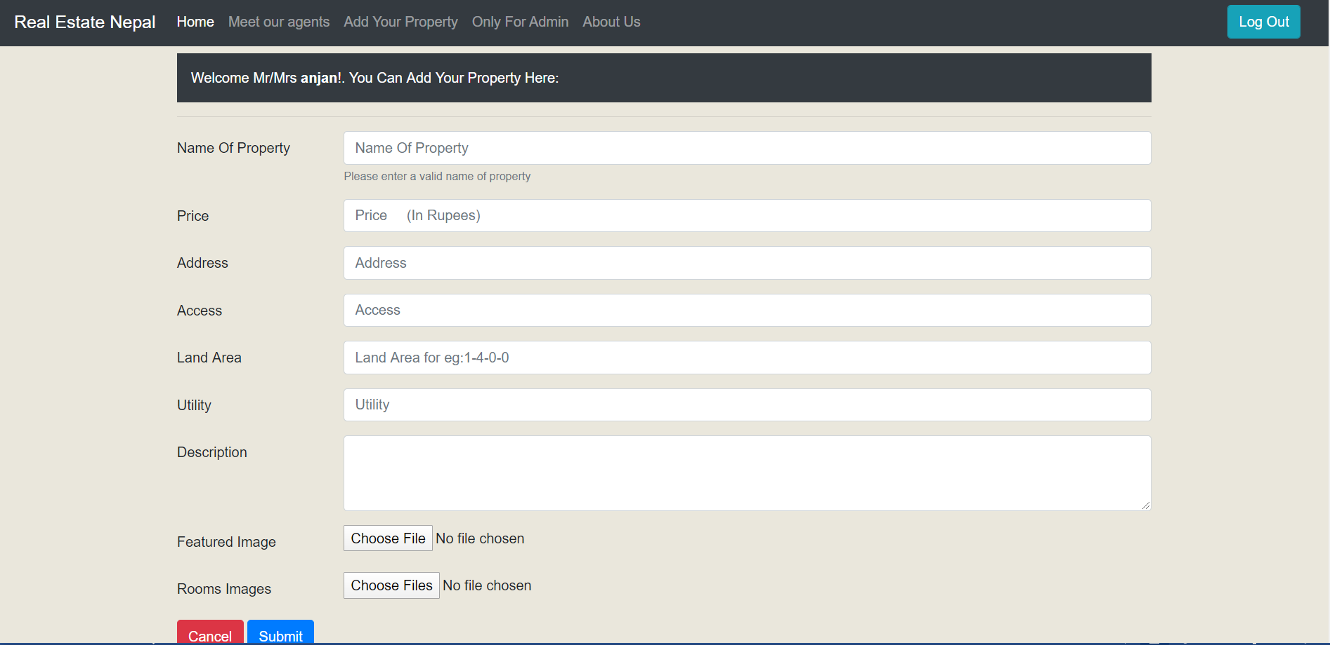

**Snapshot of Home page**

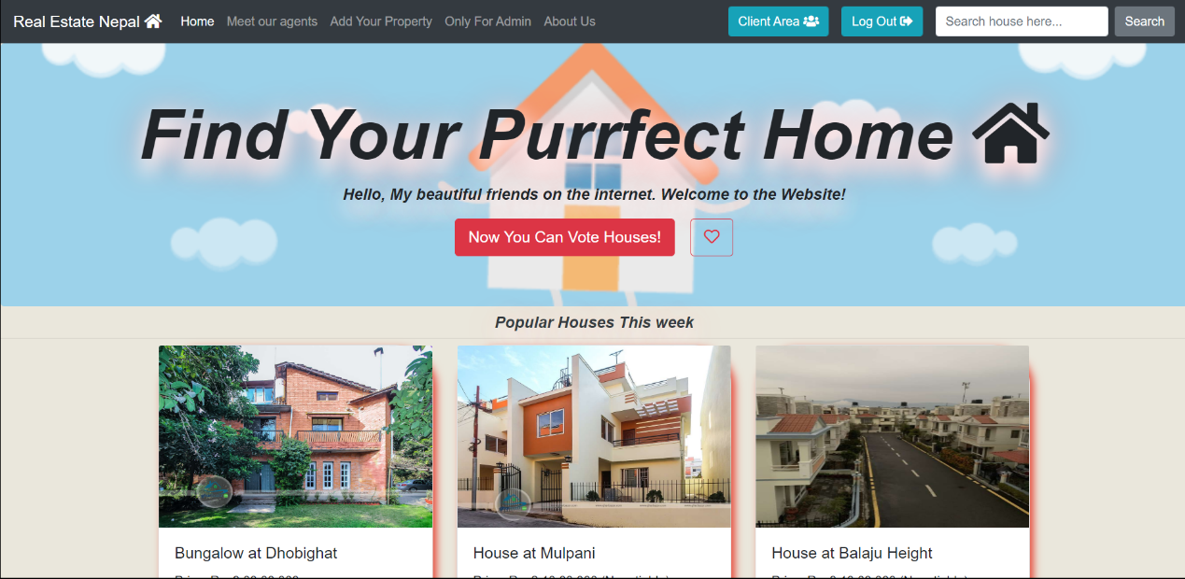

**Snapshot of Seller Profile**

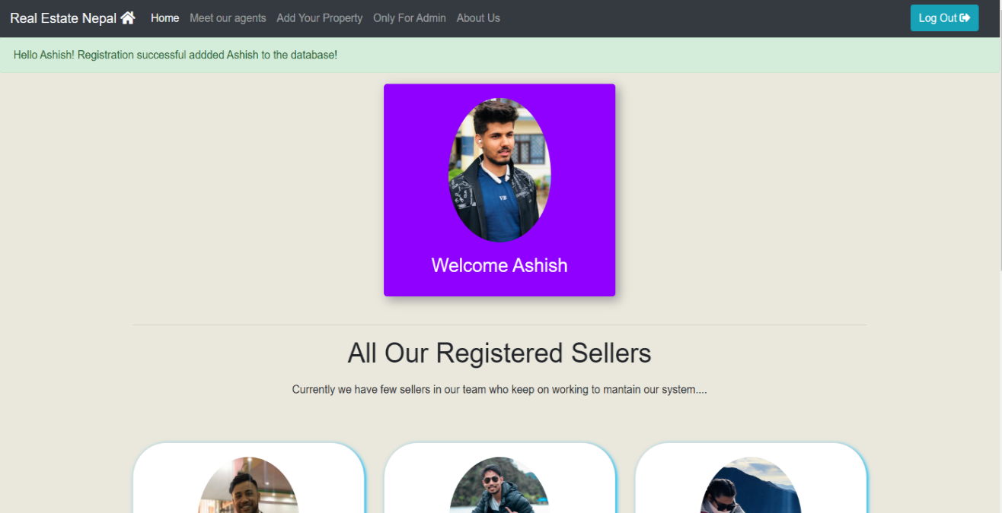

**Snapshot of Seller Listings**

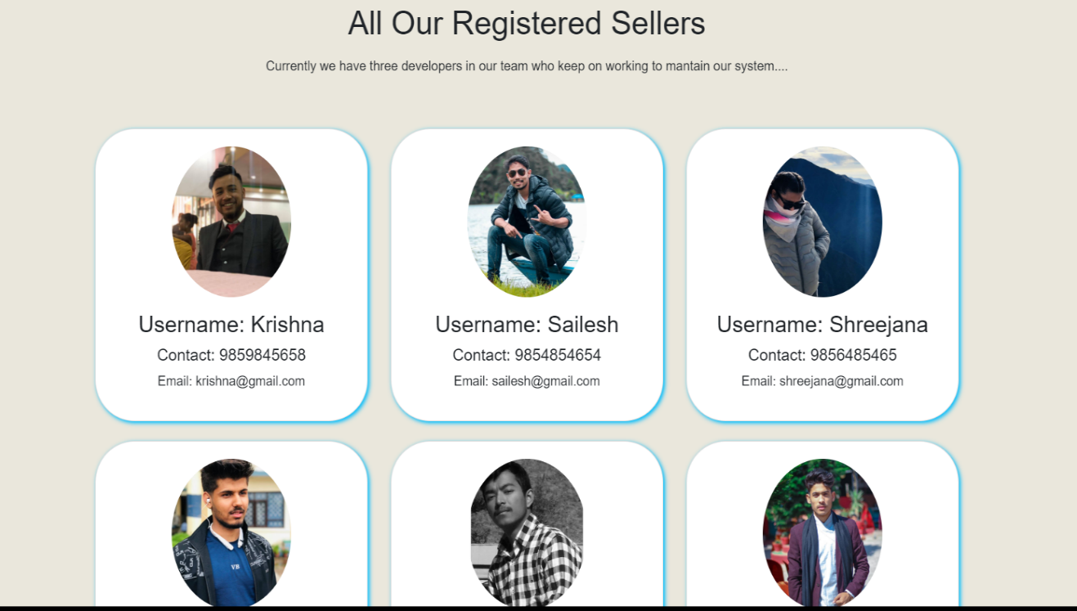

**Snapshot of Admin Panel**

